**Business Requirements Document**

**Tax Reporting System**

**Australia Requirements**

**V2.0**

**Revision History**

All revisions to this document must be recorded below.

|  |  |  |  |
| --- | --- | --- | --- |
| Date of Change | Version | Edited By | Description of Change |
| 04/13/2020 | 1.0 | Sarah Combs | First version |
| 04/21/2020 | 2.0 | Sarah Combs | The following updates were made to the document based on the feedback received from the user and technical team:   * Existing Functionality (2d) – As requested by the technical team, statements were added to clarify that there are no changes to the Edit Agent and Delete Agent functions available on the Agent Details screen * Agent Details Export File (4d) – statement was added to clarify that the Company column will always be included in the Agent Details Export file * Transfer Bookings Screen Displayed from Agent Details (5) – mockup was added for this screen * Bookings (7) – mockup was updated to illustrate that only one company will display on this screen * IRS Files (10) – requirement to select the company when generating the IRS files was removed as requested by the user |
|  |  |  |  |

Contents

Purpose 4

Glossary 4

Assumptions and Dependencies 4

Out of Scope 4

System Features 5

1. Mainframe Bookings File 5

2. Agent Details Grid (Screen) 6

3. Agent Details Screen 7

4. Agent Details Export File 8

5. Transfer Bookings Screen Displayed from Agent Details 9

6. Transfer Bookings Screen Displayed from Main Menu 10

7. Bookings Screen 11

8. 1099 NEC Form 12

9. 1099 NEC Letter Template 13

10. IRS Files 15

Stakeholders Impacted 16

**Purpose**

The purpose of this project is to make the necessary changes to the 1099 Tax Reporting System for the Australia project.

**Glossary**

| **Term** | **Description** |
| --- | --- |
| Company A | Financial company for Australian bookings |
| Company C | Financial company for non-Australian bookings |

**Assumptions and Dependencies**

| **ID** | **Assumption** | **Description** |
| --- | --- | --- |
|  | Agent Bookings Report | There is no requirement to display the financial company on the Agent Bookings Report that is accessed from the Agent Details screen. |
|  |  |  |

**Out of Scope**

| **ID** | **Out of Scope** | **Description** |
| --- | --- | --- |
|  | AUD Bookings | The following requirement has been removed due to the fact that North American agencies will only be set up to book Australian cruises in USD:  Commission earned by a North America agency for an Australia cruise in a currency other than USD, must be converted to USD prior to generating a 1099 invoice. |

**System Features**

The following section describes the detailed requirements associated with this project.

## Mainframe Bookings File

* 1. A new “Company” column was added to the mainframe bookings file that identifies the financial company the booking is associated with. This file contains the commissions earned by travel agencies for the tax year and is manually uploaded into the Tax Reporting System.
  2. The new “Company” column will be populated with a “C” (Carnival Cruise Line) for non-Australian bookings or “A” (Carnival PLC) for Australian bookings.
  3. There is no change to the current file upload process.

## Agent Details Grid (Screen)

* 1. Provide the ability to identify the total number of bookings made under Company A and Company C by travel agency on the Agent Details screen
  2. Travel agencies may be listed twice if they earned commission for bookings made for both Company A and Company C
  3. User Interface:
     1. A new column labeled “Company” should be added between the “# of Bookings” and “Tax ID” columns that will indicate the company the bookings are associated with
     2. The possible column values are “C” for non-Australian bookings and “A” for Australian bookings
  4. Existing Functionality:
     1. There are no changes to the Edit Agent screen that displays when clicking the Edit option in the Agent Details grid
     2. The Edit Agent option will display for each row in the grid when travel agencies are listed twice because they have bookings for both Company A and C
     3. There are not changes to the existing Delete functionality

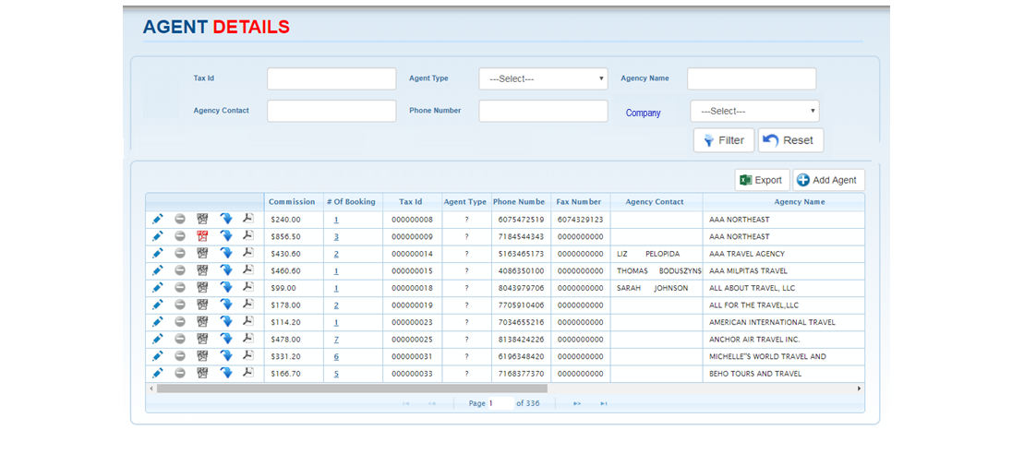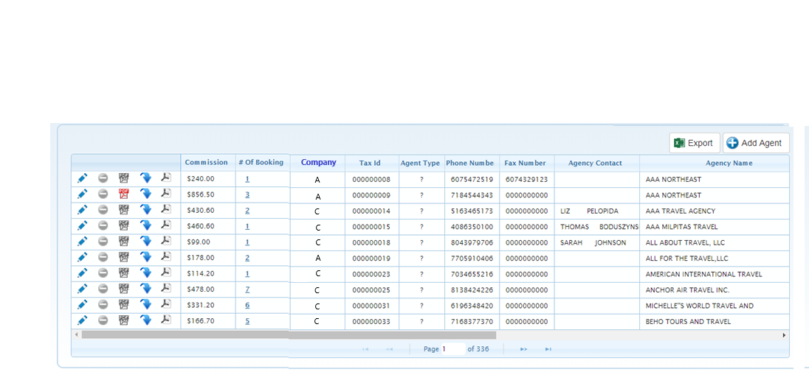

## Agent Details Screen

* 1. Provide the ability to filter agency bookings by financial company on the Agent Details screen
  2. Upon initial display of the Agent Details screen the system will display all bookings for Company A and C
  3. When filtering by company, the system should only display the agencies/bookings associated with the selected company
  4. User Interface:
     1. Provide a new dropdown list labeled “Company” on the Agent Details screen
     2. The Company list should be auto populated with the following values: “Company A” for Australian bookings and “Company C” for non-Australian bookings
     3. The Company filter is combinable with the existing filters on the screen



## Agent Details Export File

* 1. Provide the ability to identify the total number of bookings associated with Company A and Company C per travel agency in the Agent Details export file that is generated from the Agent Details screen
  2. A new column labeled “Company” should be added between the “NoOfBookings” and “Commission” columns in the file
  3. The possible values should be the same as the values on the Agent Details screen; “C” for non-Australian bookings and “A” for Australian bookings
  4. The Company column will always be included in the file even when the data is filtered for one specific company

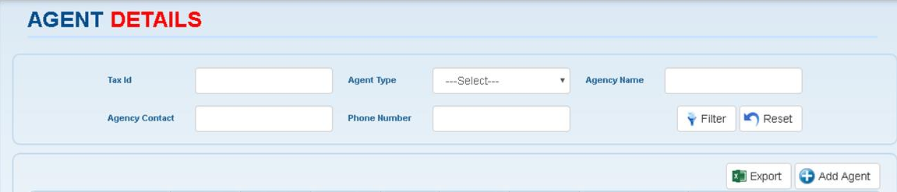

**Agent Details File Excerpt:**

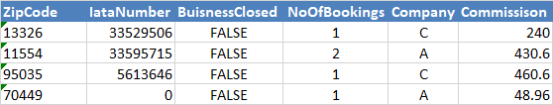

## Transfer Bookings Screen Displayed from Agent Details

* 1. Provide the ability to identify the Company the booking is associated with in the “Agent From” and “Agent To” grids that display on the Transfer Bookings screen that is accessed from the Agent Details grid
  2. User Interface:
     1. A new column labeled “Company” should be added between the “Booking Number” and “Ship Code” columns that will indicate the company the booking is associated with
     2. The possible values are “C” for non-Australian bookings and “A” for Australian bookings
     3. The same company will display for all bookings on this screen since this screen is accessed from a single line item on the Agent Details grid

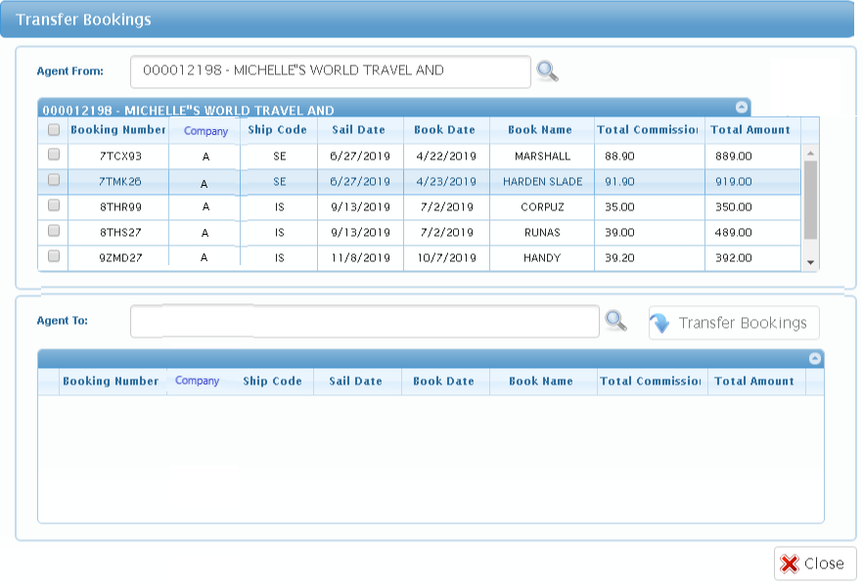

## Transfer Bookings Screen Displayed from Main Menu

* 1. Provide the ability to identify the Company the booking is associated with in the “Agent From” and “Agent To” grids that display on the Transfer Bookings screen that is accessed from the main menu
  2. User Interface:
     1. A new column labeled “Company” should be added between the “Booking Number” and “Ship Code” columns that will indicate the company the bookings are associated with
     2. The possible values are “C” for non-Australian bookings and “A” for Australian bookings

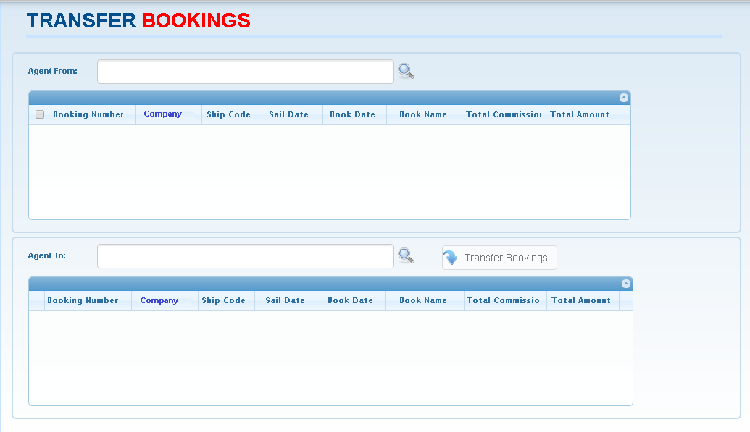

## Bookings Screen

* 1. Provide the ability to identify the Company the booking is associated with on the “Bookings” screen
  2. User Interface:
     1. A new column labeled “Company” should be added between the “Booking #” and “Tax Year” columns that will indicate the company the booking is associated with
     2. The possible values are “C” for non-Australian bookings and “A” for Australian bookings
     3. The same company will display for all bookings on this screen since this screen is accessed from a single line item on the Agent Details grid

## 1099 NEC Form

* 1. A separate EIN (Employer Identification Number) will be used to differentiate the two financial companies (A and C); this is reflected in the “Payers TIN” section of the 1099 NEC form
  2. The system will be required to generate separate 1099 NEC forms for Company A and Company C
  3. 1099 NEC forms issued for North American agencies that booked Australian cruises must reflect the information for Carnival PLC trading as Carnival Cruise Line in the “Payers” information section of the form
  4. The threshold to submit a 1099 NEC will be calculated as the total earned by EIN; not as the total earned by travel agency as illustrated in the examples below (assumption is the threshold for submitting a 1099 NEC is $600 or more for commission earned in a given year):
     1. A US agency earns $400 commission for bookings on North American sailings and $500 commission for bookings on Australian sailings – A 1099 NEC would NOT be generated for either company
     2. A US agency earns $600 commission for bookings on North American sailings and $500 commission for bookings on Australian sailings – A 1099 NEC would be generated for Company C (Carnival Corporation); a 1099 NEC would NOT be generated for Company A (Carnival Australia)
     3. A US agency earns $600 commission for bookings on North American sailings and $600 commission for bookings on Australian sailings – A 1099 NEC would be generated for Company C (Carnival Corporation) and another 1099 NEC would be generated for Company A (Carnival Australia)
     4. A US agency earns $400 commission for bookings on North American sailings and $600 commission for bookings on Australian sailings – A 1099 NEC would NOT be generated for Company C (Carnival Corporation); a 1099 NEC would be generated for Company A (Carnival Australia)

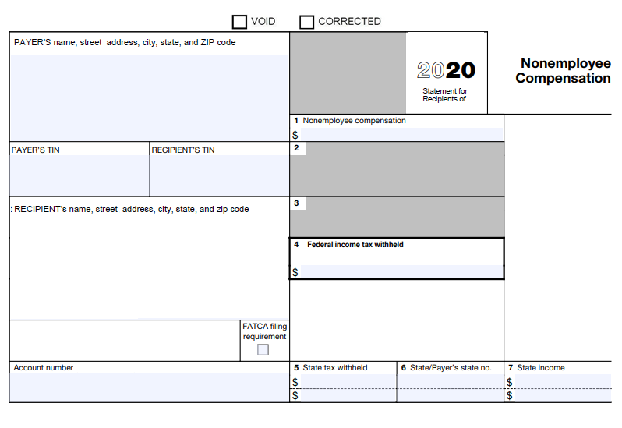

## 1099 NEC Letter Template

* 1. The logo on the 1099 NEC letter template must reflect the Carnival Corporation logo
  2. The reference line should reflect “Substitute Form 1099 NEC”
  3. The verbiage in the body of the letter should reflect the corporation name *(pending exact name from business)*

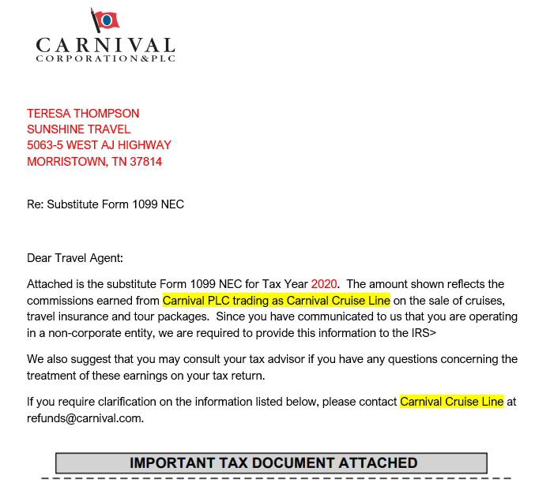

## IRS Files

* 1. The system will provide the ability to generate two separate IRS files for each EIN (financial company); this includes the 3 files that can be generated from the “Get IRS File to Upload” menu:
     1. Original / Replace
     2. Correction
     3. Test File
  2. The system will automatically generate both files; one for Company A and another for Company C when any of the 3 options available from the Get IRS File to Upload is selected

**Stakeholders Impacted**

The following matrix describes the stakeholders and project roles (defined below) as it pertains to the requirements planning and management associated with CQ #209467.

Project roles requiring representative sign-off during various project phases:

* **Business Sponsor:** a person or group of persons sponsoring the project initiative.
* **Accountable:** is accountable for project success.
* **Consulted:** is directly impacted by the new product or product changes and is consulted prior to completing the work. May participate in requirements sessions, design reviews, testing, etc…

Project roles NOT requiring representative sign-off during various project phases:

* **Responsible:** does the work necessary to deliver the new product or product changes.
* **Informed:** is indirectly impacted by the new product or product changes.

| **Stakeholder Name** | **Represents** | **Project Role** |
| --- | --- | --- |
| Ricardo Rodriguez | Revenue Accounting | Business Sponsor |
| Erica Brown | Revenue Accounting | Consulted |